**THE TRANSITION**

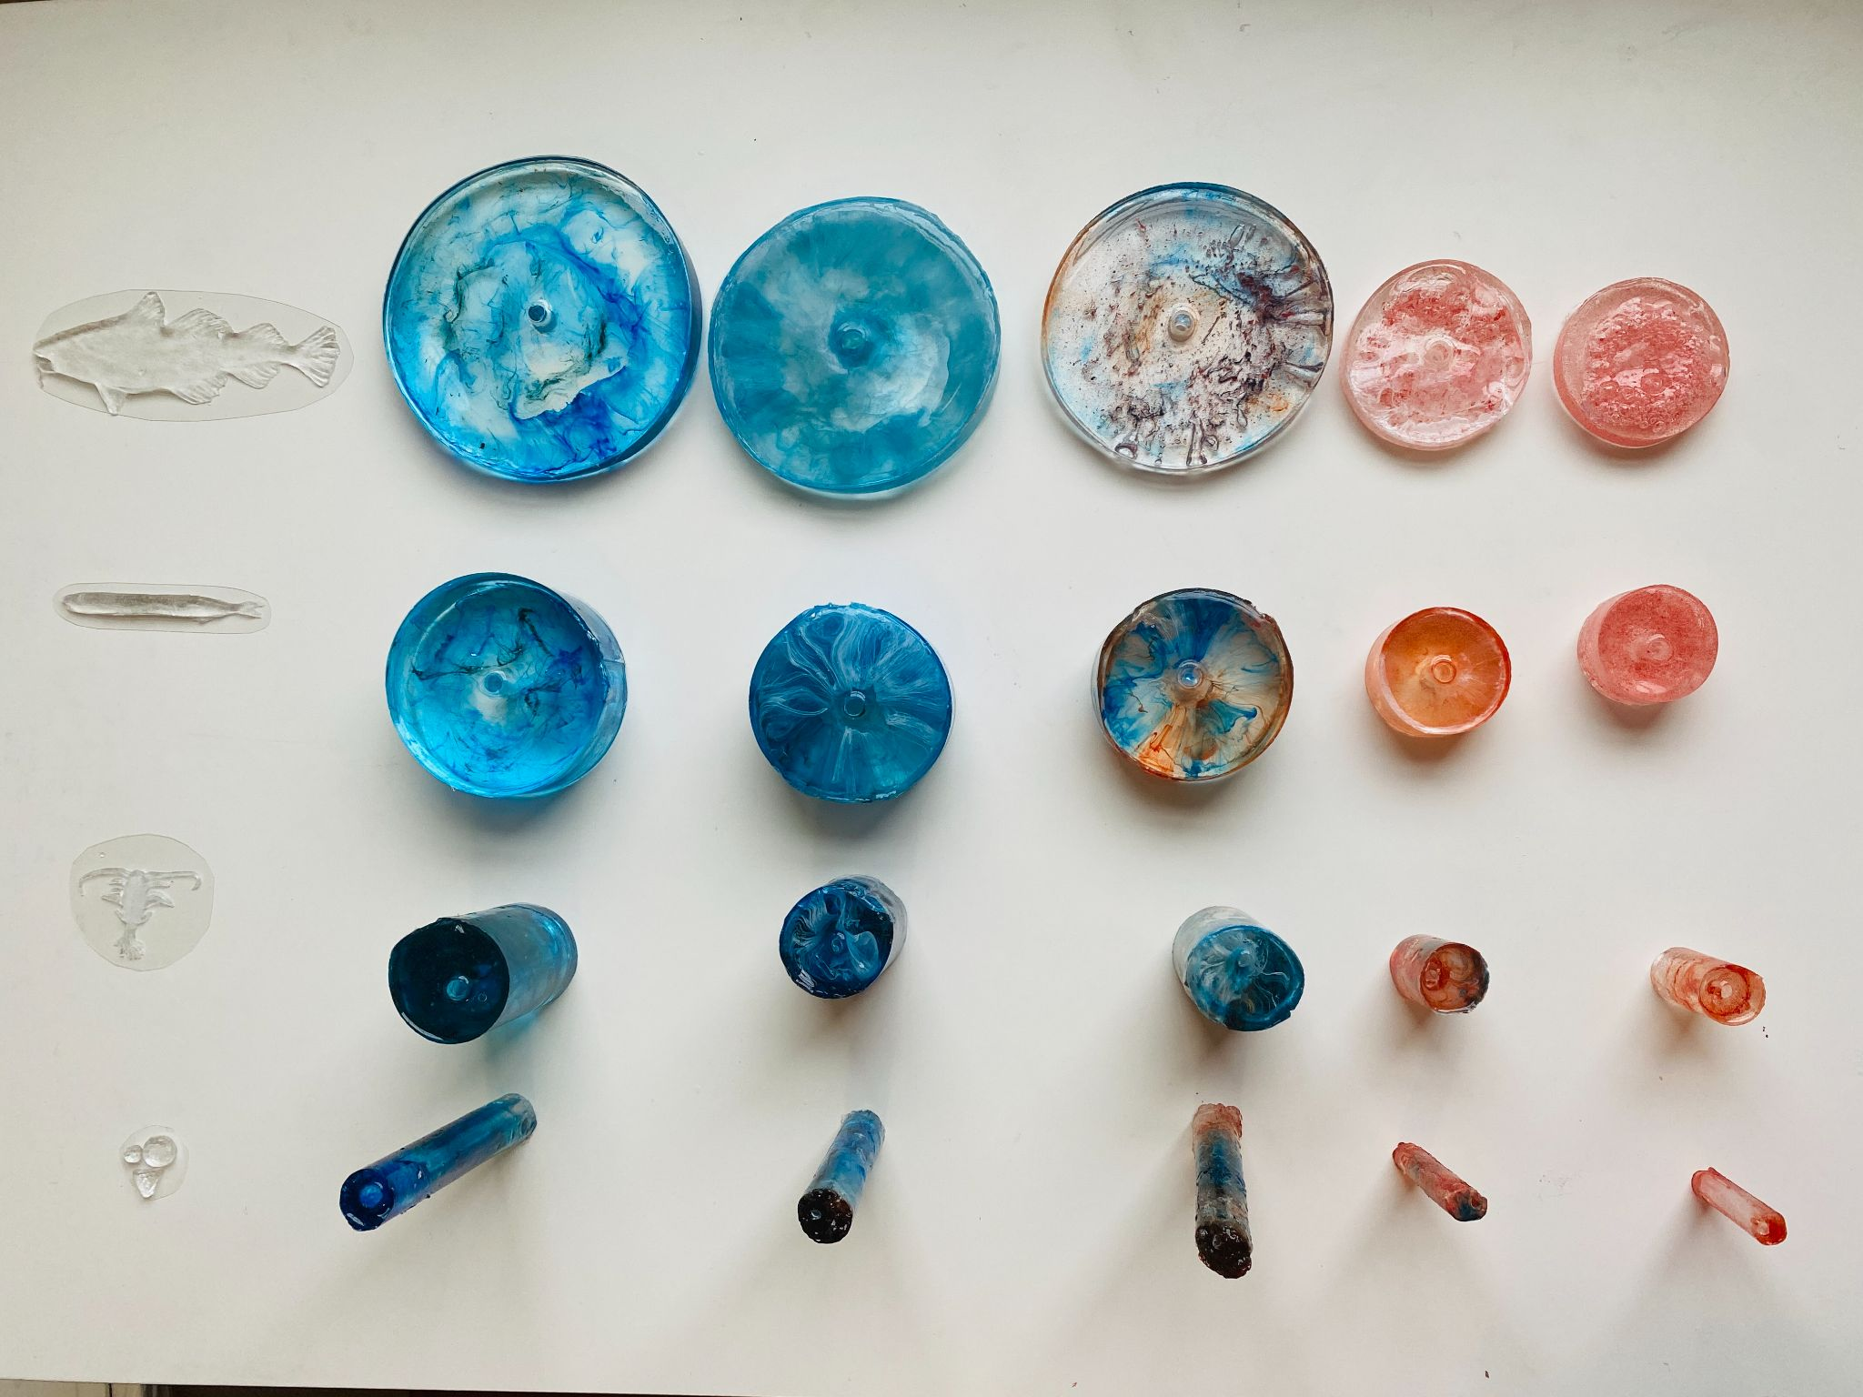

*Figure 1. Top view of final pieces*

**Introduction**

The 2021 RI C-AIM Vis-a-Thon program is geared at fostering art and science collaborations between students throughout Rhode Island. This month's letter features the collaboration between Catrina Nowakowski, a PhD student at the University of Rhode Island's Graduate School of Oceanography who studies food webs in the Gulf of Maine, and Eunhyung (Julie) Chung, a MA student at the Rhode Island School of Design studying environmental education through art. Despite their different backgrounds, this collaboration highlighted one of their shared goals: using art to break down the perceived entry level around understanding science. Together, they were able to take both of their skill sets and work out how to visually reframe food web data to illustrate three important concepts described below. The resulting sculpture provokes an initial visceral reaction before the viewer can look closer to interpret how animal size across the food web is shrinking with the warming ocean water.

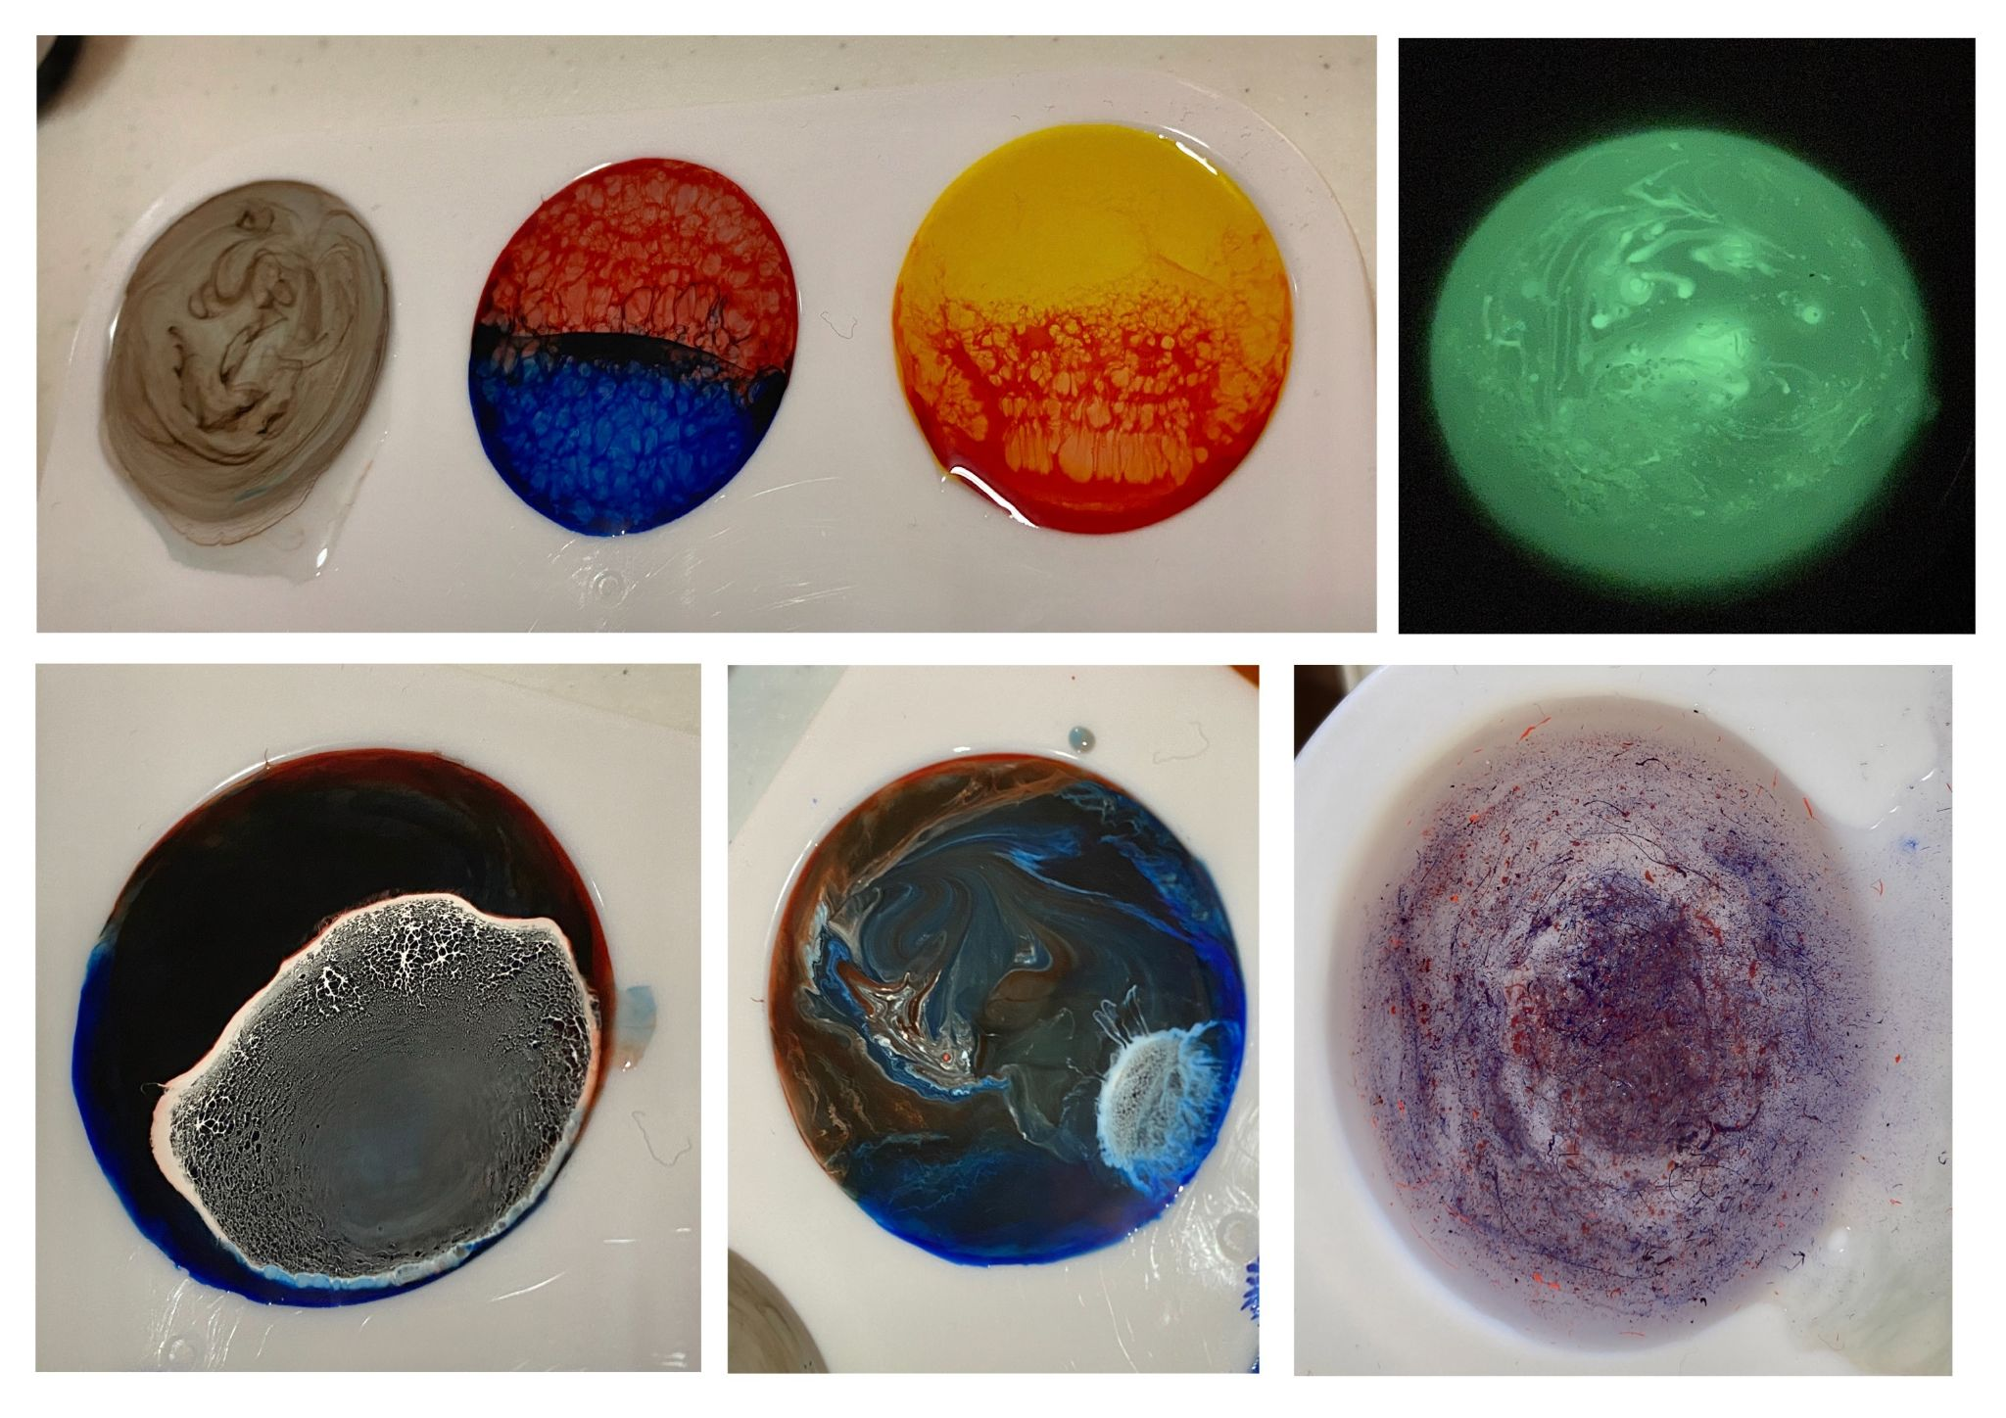

*Figure Two. Initial material experimentation*

Over the course of the month, the two collaborators worked hard to conceptualize the design and did a TON of material experimentation (see the second picture). They specifically focused on simplifying the final figure to tell the story behind the food webs clearly and learning how to control the material, a clear resin dyed with a combination of alcohol and acrylic based colors.

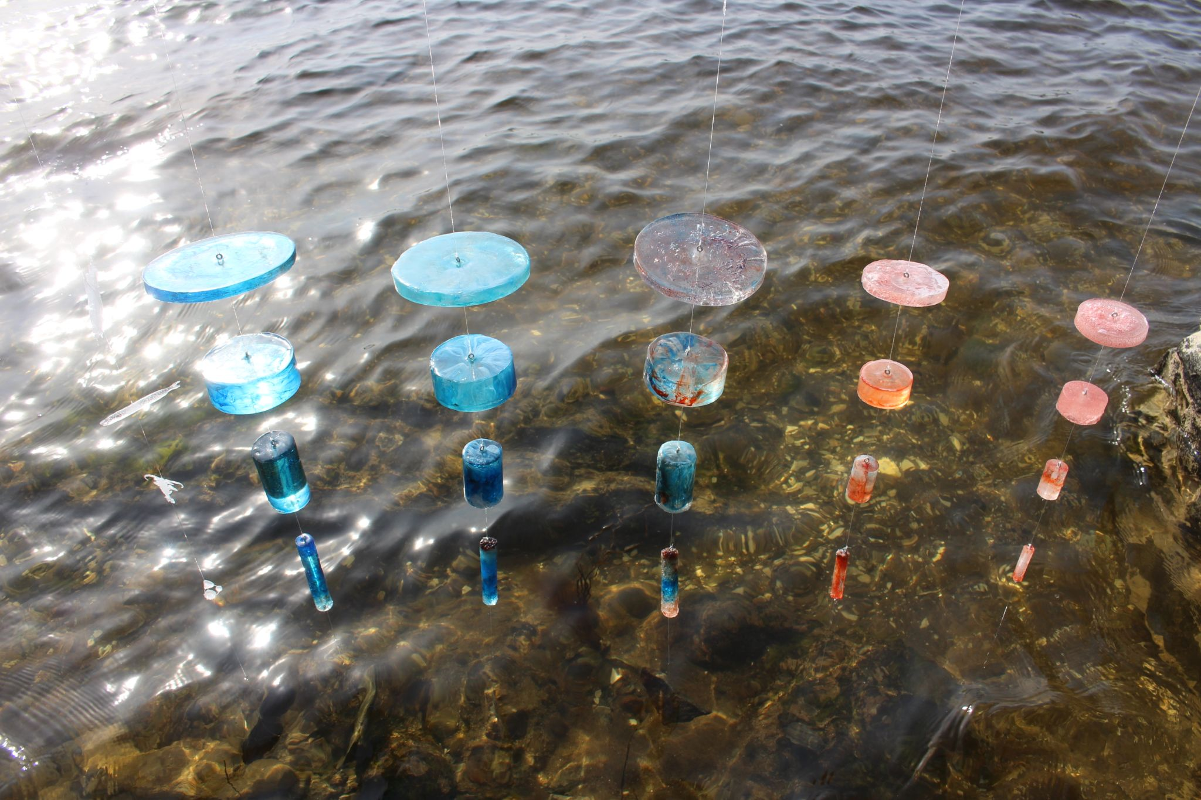

*Figure Three. Outdoor Installation*

**Project description**

**"The Transition"** is a 36 X 14" sized site-specific sculpture made out of resin. It is a research-based collaboration between arts and sciences that tells the story behind the data around how much marine food webs depend on the small animals at the bottom of the food web and how climate change affects marine life. Our goal is to show the public the importance of plankton in sustaining the system and how humans are actually connected to them through the food we eat.

We focused on four marine animals and three central concepts around the marine food web system: ENERGY / SIZE / TEMPERATURE. The animals include codfish, sand lace, copepods (zooplankton), and phytoplankton. In the Biomass Pyramid, the bigger the animal is, the smaller the energy is transferred. We used an inverted triangle shape to show the inverse relationship between size of the animals and energy transmitted. And we assigned three visual languages to the five columns that we made based on the scientific data from 2004 to 2016.

**Color**: ocean temperature

**Width**: size of the animals

**Height & Density of the ink**: Energy saved as Biomass

The width indicates the size relationships in the marine food web, the height of each model and the density of the ink shows how much energy gets transferred, and color represents temperature changes. As ocean temperature has increased over the last decade, we have also observed a shift from large to smaller plankton. The decrease in size then directly reduces the amount of energy transferred up the food web; which inturn, leads to a decrease in the overall size of large animals. The upper part of the food web becomes more transparent and disappears as the temperature goes up and size goes down. Through our work, the public will understand how much large animals are dependent on such tiny plankton and how humans and nature are interconnected.